Linux Programming: assignment-9
- Write a shell script using if…else to check if a number is even or odd.
  - bash
#!/bin/bash echo “enter a number:”
read num if [ $((num % 2)) -eq 0 ]
then echo "$num is even." else
echo "$num is odd."
Fi
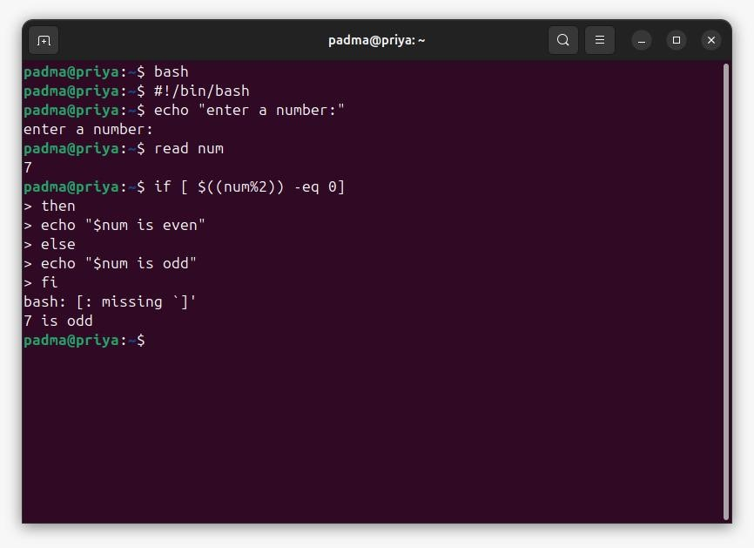
- Explain the difference between if and case statements in bash
Features | If statement | case statement
Purpose | Used for conditional testing based on logical or comparison expressions. | Used for pattern matching and also to compare one value against many patterns
Syntax | if [ condition ]; then ... elif [ condition ]; then ...  else ... fi | case variable in pattern1) ... ;; pattern2) ... ;; *) ... ;; esac
Performance | May require multiple comparisons and elif blocks. | Easier to read and more efficient for many discrete matches.
Best for | Numerical, string, and file comparisons. | Matching specific values or patterns
Example | bash if [ $num -gt 0 ];  then echo "Positive"; else  echo "Non-positive"; fi | bash case $fruit in  apple) echo "Apple";; banana) echo "Banana";; *) echo "Unknown";;  esac
- Write a script to find the largest of three numbers entered by the user
  - bash
#!/bin/bash
echo "Enter the first number:"
read num1
echo "Enter the second number:"
read num2
echo "Enter the third number:" read num3
if [ $num1 -ge $num2 ] && [ $num1 -ge $num3 ]; then echo "$num1 is the largest number."
elif [ $num2 -ge $num1 ] && [ $num2 -ge $num3 ]; then
echo "$num2 is the largest number." else echo "$num3 is the largest number."
Fi
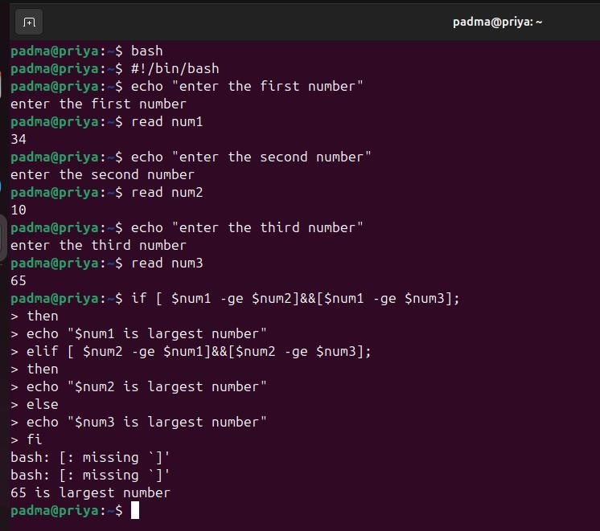
- How do you use a for loop to traverse an array in bash? Give an example. The array is defined as arr=(123, “Abs”, -2.3, ‘A’, 23.56, 0).
  - #!/bin/bash arr=(123 "Abs" -2.3 'A' 23.56 0) echo "Array elements are:"
for element in "${arr[@]}"
do
echo "$element"
done
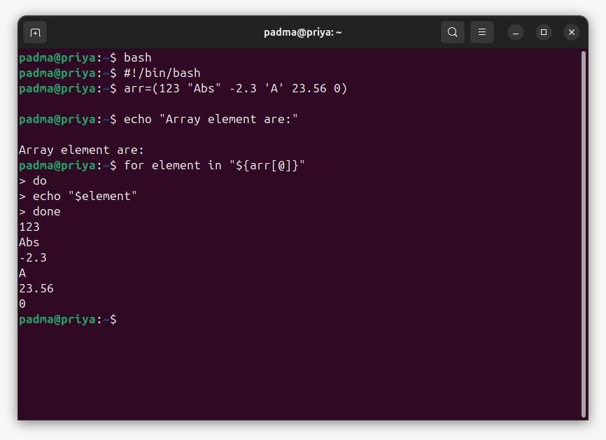
- Write a shell script to loop through all files in the current directory and display their names.
  - #!/bin/bash echo "Files in the current directory are:" for file in *
do
if [ -f "$file" ]; then
echo "$file"
fi
done
- What is the difference between while and until loops in bash?
Features | while loop | Until loop
Condition check | Executes while the condition is true. | Executes until the condition is true.
Loops stops when | Condition becomes false. | Condition becomes true.
Use case | used when you want to loop as long as a condition holds true. | Used when you want to loop until a certain condition is met.
Example | bash #!/bin/bash count=1 while [ $count -le 5 ] do echo "Count = $count"  ((count++)) done | bash #!/bin/bash count=1 until [ $count -gt 5 ] do echo "Count = $count"  ((count++)) done
- Write a countdown timer script using a while loop ?
  - #!/bin/bash echo "Enter the countdown time in seconds:" read time while [ $time -gt 0 ] do
echo "Time remaining: $time seconds" sleep 1
((time--)) done echo "⏰ Time's up!"
- How do you use break and continue statements in loops? Give examples.
  - Break
The break command terminates the entire loop immediately.
No further iterations are executed.
  - Example: bash #!/bin/bash
for i in {1..10} do
if [ $i -eq 5 ]; then
echo "Breaking the loop at i = $i"
break
fi
echo "Number: $i"
done
  - Continue:
The continue command skips the current iteration.
Moves to the next iteration of the loop.
  - Example: bash #!/bin/bash
for i in {1..10} do
if [ $i -eq 5 ]; then
echo "Skipping number $i"
continue
fi
echo "Number: $i"
done
- Write a script to check if a file exists or not using the if and else loop.
  - Bash
#!/bin/bash echo "Enter the file name:" read filename if [ -f "$filename" ]; then echo " File '$filename' exists." else
echo " File '$filename' does not exist."
fi
- Write a script to calculate factorial of a number using for loop
  - bash
#!/bin/bash echo "Enter a number:" read num
fact=1
for (( i=1; i<=num; i++ )) do
fact=$((fact * i)) done
echo "The factorial of $num is: $fact"
Name: Akshitha reddy
USN: ENG24CY0090
Roll no: 47
Section: 3C
------------------------------- x---------------------------------x------------------------------------

